Declaration

I, hereby declare that the work presented in this dissertation entitled “Tic - Tac - Toe game with graphics” has been done by me, and this dissertation embodies my own work.

|  |  |
| --- | --- |
| Name of Project | Tic - Tac - Toe game with graphics |
| Author Name | Abdullah Al Yeamin Maruf |
| Semester | Summer 2018 |

Acknowledgment

First of all, I am grateful C project is a golden opportunity for learning and self-development. I consider myself very lucky. I cannot express enough thanks to my course teacher for her continued support and encouragement, Mrs Raihana Zannat my course teacher help a lot to complete this project.

My completion of this project could not have been accomplished without the support of my teacher. She guided and keep me on the correct path. A humble ‘Thank you’ Madam. Her technical and editorial advice was essential to the completion of this dissertation and has taught me innumerable lessons and insights on the workings of academic research in general. I am highly indebted to her for her able guidance, valuable suggestions and constant encouragement during the course of this work.

Finally, I would like to thank our family members for their love, continues inspiration and support with regard to my present work.

Preface

This report is an introduction to the Tic-Tac-Toe game in C programming. Anybody, who doesn’t know even the basics of Tic-Tac-Toe in C, will be certainly able to understand and gain the great knowledge from this report. The core theme of the report focuses on the development of Tic-Tac-Toe game in C language.

The report also contains the strategy of making Tic-Tac-Toe game which serve a good idea to make a Tic-Tac-Toe game program in C language to the programmer.

Abstract

The game Tic-Tac-Toe had an early variant which began in the first century in the Roman Empire. During that time it was called Terni Lapilli where the players only had three pieces and had to move around the empty spaces to play. The actual game of tic-tac-toe could be traced back to ancient Egypt.

The game was also known during that time as Three Men's Morris. The first reference to Noughts and crosses was made in 1864 in a British novel called Can You Forgive He. For many years the game was referred to as noughts and crosses but was changed in the 20th century by the United States to Tic-Tac-Toe.

This game is very popular and is fairly simple by itself. It is actually a two player game. In this game, there is a board with n x n squares. In my game, it is 3 x 3 squares. The goal of Tic-Tac-Toe is to be one of the players to get three same symbols in a row - horizontally, vertically or diagonally - on a 3 x 3 grid.

Table of Contents

**Page No**

Declaration …………………………………………………………….. 1

Acknowledgment …………………………………………………….. 1

Preface  ………………………………………………………………….. 2

Abstract ………………………………………………………………… 2

Chapter 01: Introduction ………………………………………….. 4

1.1 WHAT IS TIC TAC TOE ………………………………………………………… 4

1.2 Motivation ………………………………………………………………………… 5

1.3 Aim of the Game ………………………………………………………………. 5

1.4 Theory of Game ………………………………………………………………… 5

1.5 The objective of this game ……………………………………………….. 6

Chapter 02: Project Methodology ………………………………… 7

2.1 outtextxy() ………………………………………………………………………. 7

2.2 Enterkey() …………………………………………………………………………. 7

2.3 display() …………………………………………………………………………… 7

2.4 Winner() …………………………………………………………………………. 7

2.5 draw() ……………………………………………………………………………… 7

2.6 end() ……………………………………………………………………………….. 7

Chapter 03: Result & Discussion ………………………………… 8

3.1 User Interface …………………………………………………………………. 8

3.2 played by two players ……………………………………………………… 9

3.3 The result is …………………………………………………………………….. 9

3.4 The Player 1 is won …………………………………………………………. 10

Chapter 04: Program for the Tic-Tac-Toe game …………….... 11

Consultation …………………………………………………………… 18

Chapter 01

1.1 WHAT IS TIC TAC TOE?

Tic-tac-toe is not a very challenging game for human beings. This game can be played in a 3x3 grid (shown in the figure 1.1). The game can be played by two players. There are two options for players:

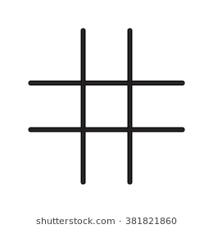 **a) Player 1 b) Player 2**

Figure 1.1: Tic-Tac-Toe game gird.

**Tic-Tac-Toe** is a paper-and-pencil game for two players, *X* and *O*, who take turns marking the spaces in a 3×3 grid. The player who succeeds in placing three of their marks in a horizontal, vertical, or diagonal row wins the game.

Game of Tic-tac-toe, won by XThe following example game is won by the first player, X:

Players soon discover that the best play from both parties leads to a draw. Hence, tic-tac-toe is most often played by young children. Tic-tac-toe is the game where n equals 3 and d equals 2. If played properly, the game will end in a draw, making tic-tac-toe a futile game.

1.2 Motivation:

The motivation for developing this game because I love playing games. Moreover, I value recent learning about the C programming languages with Graphics as well as seeing how dynamic and beautiful the game is. When I developing this game with graphics I feel very happy. When I played my own developed game it’s really make me so proud and happy.

1.3 Aim of the Game:

This game is developed to help computer science students learn about application designing using C graphics from their basic capabilities. In this game I will developed more features in future. Some features given bellow:

* **More levels:** I can try to implement different levels which will feature different grid sizes like 3×3, 4×4, 5×5, etc. One has to use variables to store level number, number of rows & columns to manage all these.
* **Human vs. Computer:** To go beyond the concept of Human vs. Human, you can try to implement separate algorithm which will mark the move based on previous move by human player!
* **Many players:** I can try to upgrade the game with more than 2 players. This will add new symbols apart from ‘X’ & ‘O’.

1.4 Theory of Game:

A player can choose between two symbols with his opponent, usual games use “X” and “O”. If first player choose “X” then the second player have to play with “O” and vice versa. A player marks any of the 3x3 squares with his symbol (may be “X” or “O”) and his aim is to create a straight line horizontally or vertically or diagonally with two intensions: a) Create a straight line before his opponent to win the game. b) Restrict his opponent from creating a straight line first. In case logically no one can create a straight line with his own symbol, the game results a tie. Hence there are only three possible results – a player wins, his opponent (human or computer) wins or it’s a tie.

This game can be played in a 3x3 grid .The game can be played by two players. A player can choose between two symbols with his opponent, usual games use “X” and “O”. If first player choose “X” then the second player have to play with “O” and vice versa.

A player marks any of the 3x3 squares with his symbol (may be “X” or “O”) and his aim is to create a straight line horizontally or vertically or diagonally with two intensions:

a) Create a straight line before his opponent to win the game.

b) Restrict his opponent from creating a straight line first. In case logically no one can create a straight line with his own symbol, the game results a tie. Hence there are only three possible results – a player wins, his opponent wins or it’s a tie.

1.5 The objective of this game

1. Playing Tic-Tac-Toe can help a child predict the outcome of another’s moves.

2. It helps children develop strategy at an early age. Though not a hard strategy it requires some thought as a youngster, such as blocking the other player and keeping them from winning while trying to win yourself.

3. It prepares them for more complex games because it helps you think of multiple things at once. As I said you must block the opponent while trying to get a straight line.

4. It can teach a child to want to win, to be better than the others. Though I wouldn’t quit consider losing/winning at Tic-Tac-Toe to be a big deal (unless I was in the National Tic-Tac-Toe league) to a child it can be a very big deal.

5. You can defiantly draw better grids, X’s, and O’s after playing the game for hours on end which is loads of fun, believe me.

Chapter 02

Project Methodology

* 2.1 outtextxy() : “Tic-Tac-Toe” & current player with its symbol on screen.
* 2.2 Enterkey() : The function scans a character from the keyboard & return its corresponding code in integer form.
* 2.3 display() : The function prints the whole Tic-Tac-Toe grid. And it maintains the getmaxx() & getmaxy() function in windows BGI graphics.
* 2.4 Winner() : The function checks if any of the two players has won the game or not.
* 2.5 draw() : The function checks if the game is draw.
* 2.6 end() : The function display the result message, close the graphics mode & exits from the program.

Chapter 03

Result & Discussion

3.1 User Interface: When we will run the code the game interface is open and first time it will want Players 1 Input choice:

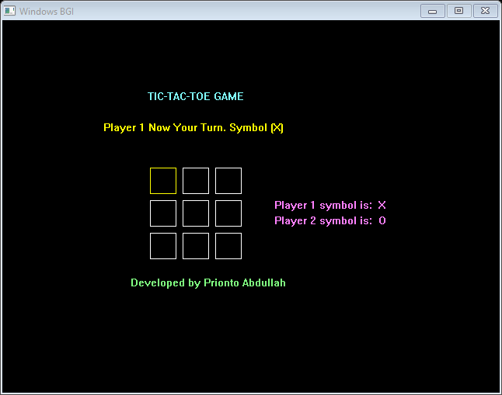

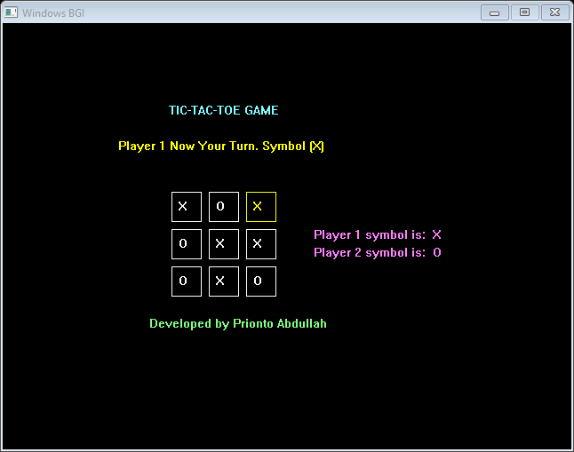3.2 played by two players: After player 1 input symbol it will want player 2 input symbol until the game over.

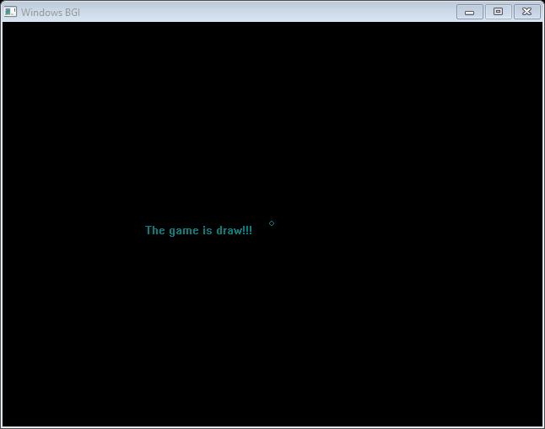 3.3 The result is: The game is draw. Because no player won the match.



3.4 The Player 1 is won: And again the players playing the game and player 1 is won this time.

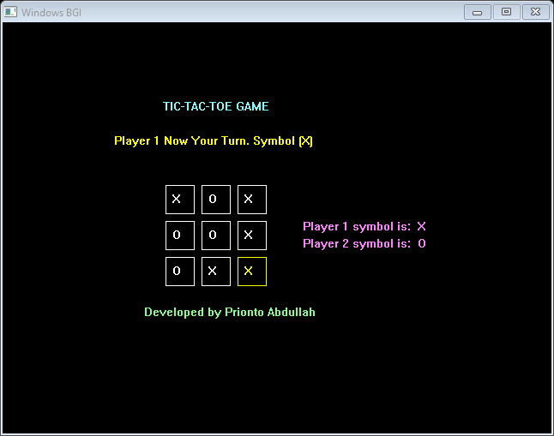

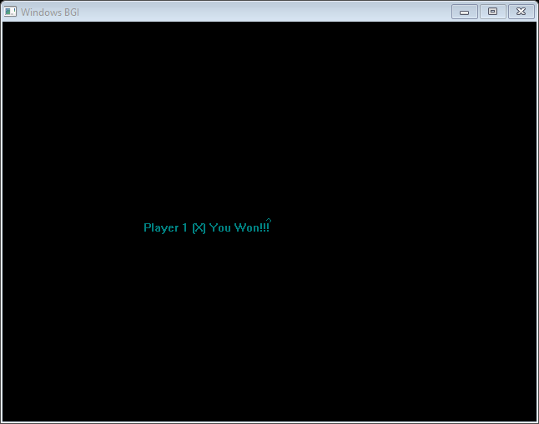





Chapter 04

Program for the Tic-Tac-Toe game

#include<stdio.h>

#include<graphics.h>

#define d 42

#define s 33

#define f 190

#define mx getmaxx()

#define my getmaxy()

char box[3][3];

int EnterKey();

void display(int,int);

int winner(int,int,int);

int draw(int,int);

void end(char *);

main()

{

int gd,gm,sx=0,sy=0,i,j,k,cnt=2,play;

char str[25],ch;

detectgraph(&gd,&gm);

initgraph(&gd,&gm,"C:\\TC\\BGI");

for(i=0; i<3; i++)

{

for(j=0; j<3; j++)

{

box[i][j]=' ';

}

}

while(1)

{

setcolor(LIGHTCYAN);

outtextxy(187,90,"TIC-TAC-TOE GAME");

setcolor(LIGHTMAGENTA);

outtextxy(350,230,"Player 1 symbol is: X ");

outtextxy(350,250,"Player 2 symbol is: O ");

play=cnt%2;

sprintf(str,"Player %d Now Your Turn. Symbol (%c)",play+1,play? 'O':'X');

setcolor(YELLOW);

outtextxy(130,130,str);

setcolor(LIGHTGREEN);

outtextxy(165,330,"Developed by Prionto Abdullah");

display(sx,sy);

ch=EnterKey();

switch(ch)

{

case 72:

if(sy!=0)

sy--;

break;

case 80:

if(sy!=2)

sy++;

break;

case 75:

if(sx!=0)

sx--;

break;

case 77:

if(sx!=2)

sx++;

break;

case ' ':

if(box[sy][sx]==' ')

{

if(play==0)

box[sy][sx]='X';

else

box[sy][sx]='O';

cnt++;

}

break;

case 'e':

case 'E':

cleardevice();

closegraph();

return 0;

default :

break;

}

if(winner(sx,sy,play)==1||draw(sx,sy)==1)

break;

}

return 0;

}

int EnterKey()

{

int ch;

ch=getch();

if(ch==0)

{

ch=getch();

return(ch);

}

return(ch);

}

void display(int sx,int sy)

{

int i,j;

char str[2];

for(i=0; i<3; i++)

{

for(j=0; j<3; j++)

{

if(j==sx&&i==sy)

setcolor(YELLOW);

else

setcolor(WHITE);

rectangle(j*d+f,i*d+f,j*d+s+f,i*d+s+f);

sprintf(str,"%c",box[i][j]);

outtextxy(j*d+8+f,i*d+8+f,str);

}

}

}

int winner(int sx,int sy,int play)

{

char str[25];

int i,j;

for(i=0; i<3; i++)

{

if((box[i][0]==box[i][1]&&box[i][0]==box[i][2]&&box[i][0]!='') || (box[0][i]==box[1][i]&&box[0][i]==box[2][i]&&box[0][i]!=' '))

{

display(sx,sy);

getch();

sprintf(str,"Player %d (%c) You Won!!!",play+1,play?'O':'X');

end(str);

return(1);

}

if((box[0][0]==box[1][1]&&box[1][1]==box[2][2]&&box[2][2]!=' ') || (box[0][2]==box[1][1]&&box[1][1]==box[2][0]&&box[2][0]!=' '))

{

display(sx,sy);

getch();

sprintf(str,"Player %d ( %c ) You Won!!!",play+1,play?'O':'X');

end(str);

return(1);

}

}

return(0);

}

int draw(int sx,int sy)

{

int i,j,k=0;

char str[25];

for(i=0; i<3; i++)

for(j=0; j<3; j++)

if(box[i][j]!=' ')

k++;

if(k==9)

{

display(sx,sy);

getch();

sprintf(str,"The game is draw!!!");

end(str);

return(1);

}

return(0);

}

void end(char *str)

{

int i,j;

delay(800);

cleardevice();

setcolor(WHITE);

outtextxy(mx/2-150,my/2,str);

setcolor(j);

circle(mx/2,my/2,i);

delay(100);

outtextxy(mx/2-150,my/2,str);

getch();

closegraph();

}

Consultation

I make Tic-Tac-Toe game successfully with the help of C language and it is very entertaining. This project took numerous steps to complete. Basically this project completed by me. I work individually to make this project. First I work for shape of game. I use many graphical condition to make it. Then I add everything of game in it. I try very much to complete it. Hopefully, it will be attractive to all.

Thank You.